[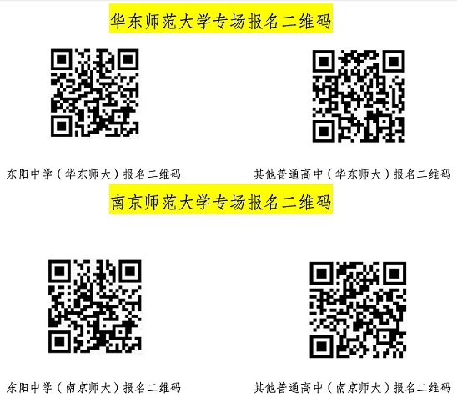](http://www.dongyang.gov.cn/picture/0/5609ea47a3aa45d2b93c92fa8e68ef1f.jpg)