[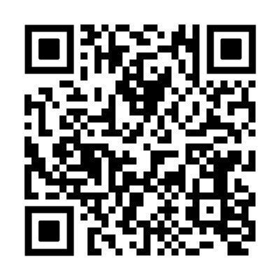](http://www.nanhu.gov.cn/picture/0/2307171937025987221.png)报名表