培养学科、数量及院校

[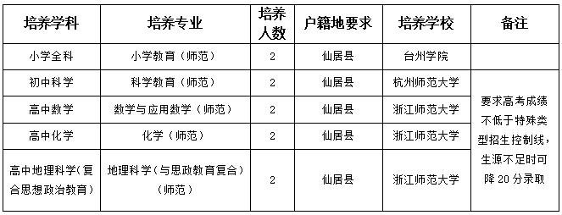](http://www.zjxj.gov.cn/picture/0/2306011005471763853.png)