[](http://www.wuch.gov.cn/picture/0/2210081754225019787.png)  [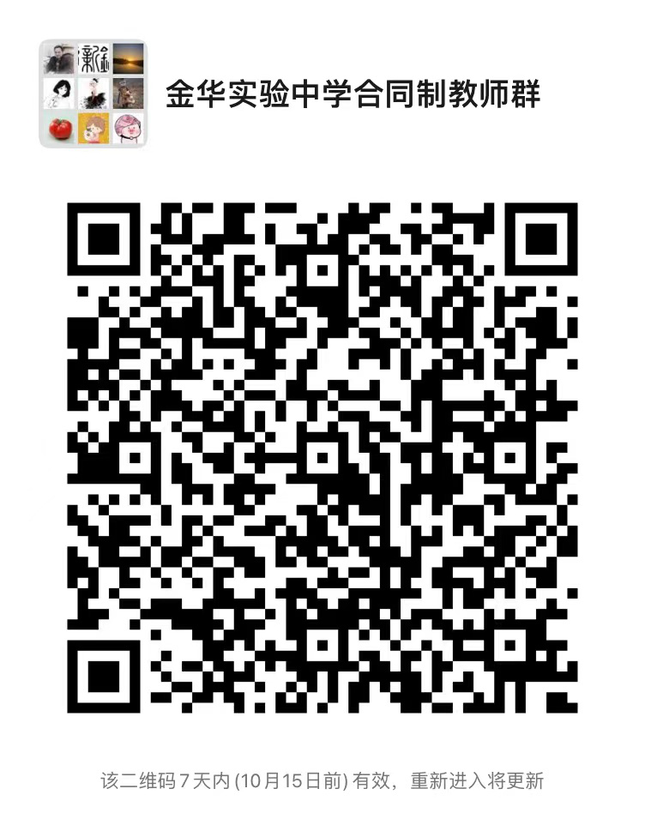](http://www.wuch.gov.cn/picture/0/2210081754225708314.png)