附：楚雄市职业高级中学外聘教师招聘岗位及条件要求

[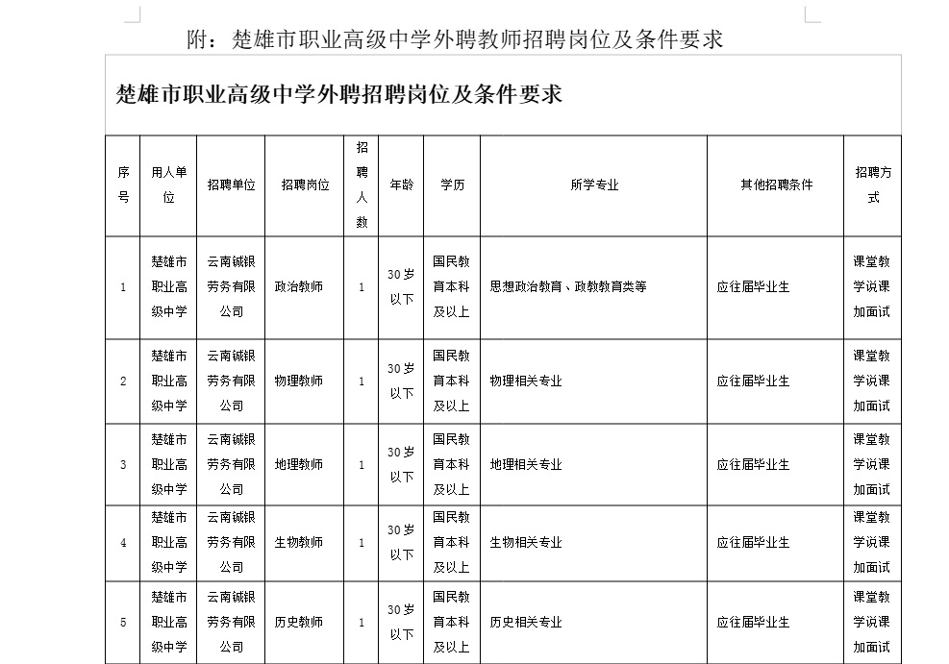](http://www.cxszz.com/img_read.aspx?name=f_pic/jpg3/F608_1.jpg)

[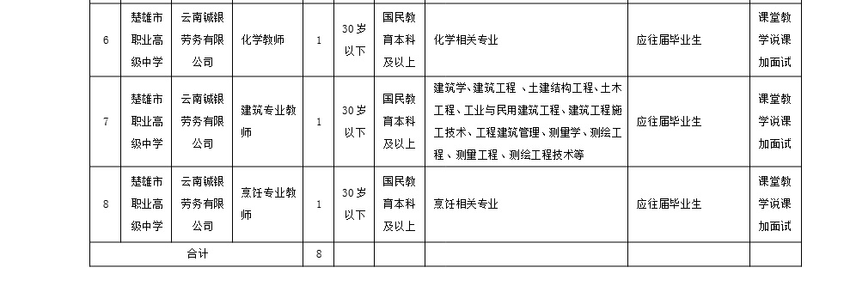](http://www.cxszz.com/img_read.aspx?name=f_pic/jpg3/F608_2.jpg)